Karnataka Valuation & E-Registration (KAVERI - 2.0)
Government of Karnataka

Functional Requirement Specifications

For KAVERI 2.0
Department of Stamps & Registration
Government of Karnataka
___________________

PAN Validation along with Income Tax data collection (SFT)

Prepared by
Centre for Smart Governance (CSG)
2nd Floor, TTMC Yeshwanthapura, BMTC Bus station
Bangalore – 3060022
Contents
1 Introduction 4
2 Document scope 4
3 Overview of the function 5
4 Functional Requirements 7
4.1 Activity Diagram 7
4.2 Process description 8
4.2.1 Application Submissions 8
4.2.2 Scrutiny 8
4.2.3 Payment – Segregate by condition 8
4.2.4 Appointment 11
4.2.5 Presentation and Registration 11
5 Input validations 11
6 Output documents 11
7 MIS Reports 12
8 External integration 13
9 Assumptions and Dependencies 13
9.1 Assumptions 13
9.2 Dependencies 13
10 Limitations 13
11 Annexure 14
11.1 Annexure – 1: Requirements as shared by the department 14
11.2 Annexure – 2: Scenarios 15
11.3 Annexure-3: Sample payload & Response of Protean PAN API 15
11.4 Annexure-4: SFT Form details 16

Acronyms
API | Application Programming Interface
CSG | Centre for Smart Governance
CV | Consideration Valuation
MV | Market Valuation
OTP | One-time password
PAN | Permanent Account Number
SR | Sub-Registrar
SRO | Sub-Registrar Office
SFT | Statement of Financial Transactions

Revision History
Date | Version | Prepared by | Reviewed By | Approved By | Description
23-10-2025 | 1.0 | Yash Veer
16-03-2026 | 2.0 | Arugolli Subhash  (BA, CSG) |  |  | - Revised the process flow  - Removal of Form 61
25-03-2025 | 2.1 | Arugolli Subhash  (BA, CSG) |  |  | - Added the MIS reports (SFT and Cash transaction more than 2 Lakh)

Introduction
The Department of Stamps and Registration (henceforth referred to as “department”) is the custodian of registered public records such as Registration of Marriages and Firms, Documents pertaining to transactions, namely sale, transfer or gift of immovable properties, mortgages, power of attorney, wills and many more. Maintenance and preservation of these critical public records is the prime responsibility of the department. The records or the information associated with registered records are to be made available to the public when requested through defined procedures. The department is also responsible for collecting stamp duty on behalf of the Government for specified transactions. The services are provided through 2 Sub-Registrar Offices (SROs), under the supervision of 34 District Registrar Offices, spread across the state.
The department has computerised the delivery of these services through the development of Kaveri software. KAVERI Online service is a web-based application of the department which provides an interface to the applicants required for documents, marriage and firm registration. It enables applicants to know the details of stamp duty, property guideline value, data entry for document registration and marriage registration, etc. The list of modules of Kaveri 2.0 is available in Annexure 1.

Document scope
This document is a Functional Requirement Specification (FRS) describing the functional features of the PAN Authentication and Statement of Financial Transactions in document registration via Kaveri 2.0. The document is prepared by the Centre for Smart Governance (CSG) and has been approved by the department. The intended audience of the document is the departmental approving authority and the development team.
The requirements below shall be applicable to the following document types:
- Sale Deed
- Gift Deed outside family definition
- Release / Relinquishment Deed outside family definition
- Exchange
- Any other document type as required by the IT Department

Overview of the function
- The overall workflow of PAN authentication will involve the following changes in the ordering of the key steps.

- In the proposed function, PAN details will be verified in real time after the payment stage for all executants through the integration of a PAN API.
- Aside from the sequence of the aforementioned steps, the key changes are outlined as follows, with further elaboration provided in the subsequent sections.
Application phase | Key changes
Application Submission | Before Scrutiny  - System must capture bifurcation of consideration into:  - Cash Component  - Non-Cash Component (Cheque / DD / RTGS / NEFT / UPI / Adjustment / Other modes)  Before presentation  - MV/CV is < INR 20L: No PAN authentication required.  - MV/CV is INR ≥20-30L: PAN authentication required  - MV/CV is INR >30L: PAN authentication + SFT Form  If PAN is not available, the applicant should fill out Form 60 and complete e-sign on the form.
Scrutiny | During scrutiny  - MV/CV is < INR 20L: SR Sends back for payment (No PAN authentication required)  - MV/CV is INR ≥20-30L: Mark PAN authentication is required.  - MV/CV is INR >30L: Mark PAN authentication + SFT Form are required.
System | - Log all the changes during the application submission and PAN Validation.  - Enforce only PAN validations for all the applications where MV or CV is more than or equal to 20 Lakhs and less than 30 Lakhs.  - Enforce both PAN validations and SFT data capture for all the applications where MV or CV is more than or equal to 30 Lakhs.  - Don’t allow the user to book the appointment for the following criteria  - Until the PAN validation is completed.  - The SFT details are digitally signed only for the application where MV or CV > 30 Lakhs.
Payment | - No changes
Appointment | - No changes
Presentation & Registration | - Display the PAN Validation details to SR and capture the decision of SR to register or reject.  - Display name as per PAN both in the applicant and department summary document

Functional Requirements

Activity Diagram
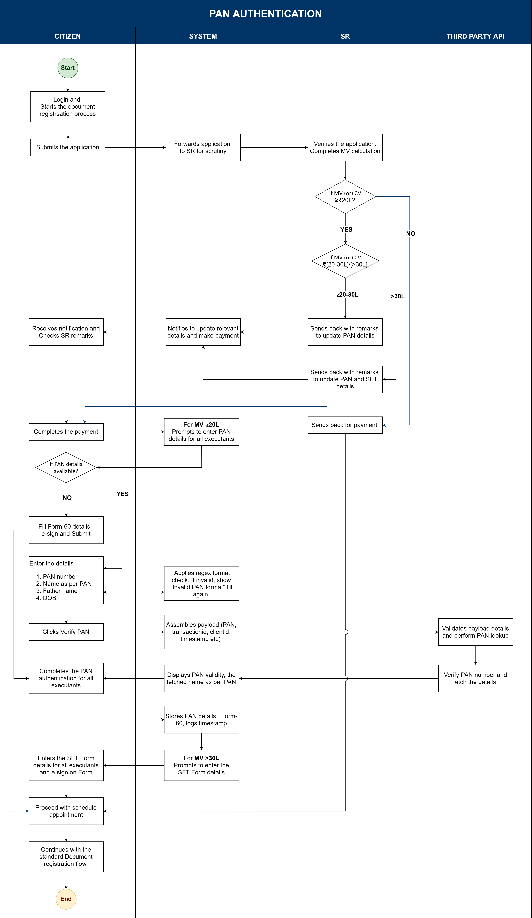

Process description

Application Submissions
- The Citizen logs into the system and initiates the document registration process.
- Completes the market valuation and provides the consideration value with the following bifurcation
  - Amount paid in cash.
  - Amount paid in non-cash
  - The system must populate the sum of a and b in the total consideration field
(Note: When a citizen provides a consideration amount, the system must ensure the Total consideration amount = Amount paid by cash + Amount paid by other)
- The citizen will complete the fee calculation and submit the application.
- The System forwards the submitted application to the concerned SR for application scrutiny.

Scrutiny
- SR receives the application for the pre-scrutiny and evaluates the MV or CV.
- Application is sent back for payment processing. Based on SR’s MV/CV, the PAN verification or the SFT data filing will be decided based on the following conditions
- If MV/CV is Less than ₹20 Lakhs: No PAN Authentication
- Else, MV/CV ≥ ₹20 and <30 Lakhs: The system should ask for PAN authentication of all the executants, including the consenting witness.
- Otherwise, for ≥ 30Lakhs, the system must capture SFT data along with PAN Validation.
- The System notifies the Citizen to update relevant details and proceed with payment.

Payment – Segregate by condition
- Citizen reviews SR's remarks and completes the Payment.
- If SR’s MV/CV < ₹20 Lakhs: System allows the user to schedule an appointment.
- If SR’s MV/CV ≥₹20L and < ₹30L: System prompts for PAN details of all executants and consenting witness.
  - If PAN details are available, the Citizen selects the “Yes” option and directly proceeds with PAN entry.
  - In the Kaveri system, the citizen enters the following details:
    - PAN Number (Mandatory)
    - Name (as per PAN) (Mandatory)
    - Father’s Name (Optional)
    - Date of Birth (Mandatory)
  - The system sends this payload for the third-party API verification.
  - The API shall return the result, and KAVERI displays a “Details as per PAN API” on success.
  - The fetched details will be stored in the database and can be used at a later stage of the application if required.
  - If PAN details are not available, the citizen selects the “No” option, and the system should generate Form 60 in PDF format with all available details in a pop-up screen.
  - Citizen will be asked to key in the missing details in Form 60 if required.
  - Citizen fills Form 60, e-signs for all executants, consenting witness and continues further.
  - System saves the Form 60 details in PDF format.
- If SR’s MV/CV > ₹30 Lakhs: System prompts for PAN and SFT Form details of all executants.
  - User completes the PAN authentication as mentioned in step 4.2.3 and proceeds further.
  - Once the PAN Authentication is completed, the system generates the SFT (Statement of Financial Transaction) Form details with available party details.
  - Citizen will be asked to key in the missing details in the SFT Form if required.
  - The system must populate the SFT form with available data and allow the citizen to key in the data which is not available. The following table gives the details of the fields of SFT.

SFT Form data fields:
Details for SFT filing
Sl. No | Report Serial Number | Party Name | Party type | Gender (for Individuals) | Person type | Father’s Name (for Individuals) | PAN | Identification Type | Identification Number | Date of Birth / Incorporation | Nationality / Country of Incorporation | Address, City / Town. Postal Code, State, Country | Mobile / Telephone Number | Other Contact Number | Email | Transaction Date | Transaction Identity | Transaction Type | Transaction Amount | Property Type | Whether the property is within municipal limits | Property Address | City / Town | Postal Code | State | Country | Stamp Value | Transaction Amount related to the person | e-Sign
1 | 2 | 3 | 4 | 5 | 6 | 7 | 8 | 9 | 10 | 11 | 12 | 13 | 14 | 15 | 16 | 17 | 18 | 19 | 20 | 21 | 22 | 23 | 24 | 25 | 26 | 27 | 28 | 29 | 30
Serial No | A unique number to be generated. | Name of the party | Executant / Claimant / Confirming Party | Male / Female / Others | To be derived from the PAN validation status.  4th character of PAN.  e.g.  P-Individual,  F-Firm,  C-Company,  H-HUF,  T-Trust,  A-Association of Persons,  B-Body of Individuals,  L-Local Authority,  J-Artificiatl Juridical Person, G-Government | To be derived from the PAN validation status. | Validate PAN | Aadhaar / Passport / TAN | Aadhar Hash/ Passport No/ TAN No | To be captured | To be captured | Available in Kaveri | Available in Kaveri | To be captured | To be captured | Registration Date | Registration Number | Nature of Document | Consideration or Market Value, whichever is higher | Agriculture /  Non-Agriculture | Yes / No | Property Description | To be collected | To be collected | To be collected | India | Stamp Duty Value | To be provided by the person

  - Citizen enters SFT details for all executants and consenting witnesses completes e-sign on SFT Form.
  - Once the SFT Form is e-Signed by all the parties, the system allows the citizen to proceed with schedule appointment.
- Upon successful appointment booking, the system continues with the standard document registration workflow

Appointment
- There will be no change in existing appointment logic.

Presentation and Registration
- SR should be able to view the following details in step 5 and capture SR’s decision for registration, if the SR reviews the details and decides to register, if the following details are available–
  - For MV/CV ≥₹20L and < ₹30L: PAN verification details or e-Singed Form 60.
  - For MV/CV ≥₹30L: PAN verification details or Form 60 and SFT Form details
- The summary document will have the name as per PAN and verification status.
- The system provides the hyperlinks of Form 60 and SFT Form to view in SR Step-5.

Input validations
- PAN will be verified, and the SFT details will be collected for the transaction of the following articles
  - Sale Deed
  - Gift Deed outside family definition
  - Release / Relinquishment Deed outside family definition
  - Exchange
  - Any other document type as required by the IT Department
- PAN Number format check.
- MV/ CV value.
MV / CV Range | Action Required | Party
< ₹20L | Direct payment (No PAN mandate) | NA
≥ ₹20L and < ₹30L | PAN Authentication mandatory | All executants and consenting witnesses  (Including represented parties)
≥ ₹30L | PAN Authentication + SFT details mandatory | All executants and consenting witnesses

- When the SR MV/CV is greater than or equal to ₹30 lakhs, and the citizen opts for Undervaluation or Impound, but the citizen-declared MV/CV is less than ₹30 lakhs, PAN validation will be mandatory.

Output documents
- Citizen summary with PAN authentication details
- E-Signed Form 60
- E-Signed SFT Form

MIS Reports
Search parameters: District, SRO, Financial year
Annexure-A
FORMAT FOR FURNISHING THE DETAILS OF THE CASH TRANSACTIONS- F Y 2025-26 (to be furnished month – wise)
Format for reporting cash payments of Rs. 2 lakh and above in the registration of Immovable Property
Sl No | Name and Address of SRO | F. Y. | Name and PAN of the seller(s) |  |  | Name and PAN of the Purchaser(s) |  |  | Total value of sale consideration (In Rs.) | Circle Rate/Value adopted, assessed, assessable by the stamp valuation Authority | Value of cash payments of Rs. 2 lakh and above(In Rs.) | Document Registration and Date of Registration
Sl No | Name and Address of SRO | F. Y. | Name | PAN | Aadhaar No | Name | PAN | Aadhaar No | Total value of sale consideration (In Rs.) |  | Value of cash payments of Rs. 2 lakh and above(In Rs.) | Document Registration No | Registration date
1 | 2 | 3 | 4 | 5 | 6 | 7 | 8 | 9 | 10 | 11 | 12 | 13 | 14

Download option: PDF/ Excel.

External integration
- This module has an integration with the external system API to verify and validate the applicant's PAN authenticity after the payment screen and before the book appointment screen.
- Existing integrations like K2, Aadhaar, etc, remain the same.

Assumptions and Dependencies

Assumptions
- PAN API will verify the PAN number and display the name as per the PAN.
- Name as per the property masters and name retrieved from PAN should be scrutinised by the SR.
- During PAN authentication,
  - Individuals: Only the principal parties, PAN details must be verified.
  - Organisation: Organisation’s PAN will be validated. Authorised signatory PAN is not required.

Dependencies
- This feature has a dependency on the third-party PAN database.

Limitations
- This application has a dependency on the third-party API, and citizens will not be able to submit the application if PAN API is not working or responds more time than the usual time, if the MV/CV more than 20 lakhs If the PAN API is not working, application submission will not be possible in case the MV/CV is more than INR 20Lakhs.
- The system will not allow the user to schedule the appointment until the PAN details are verified or the Form 60 is signed using an Aadhar-based e-sign, when the market value or the consideration value is more than INR 20.
- The system will not allow the user to schedule the appointment until the PAN details are verified or the Form 60 and SFT are signed using an Aadhar-based e-sign, when the market value or the consideration value is INR more than 30 Lakhs.
- If any user does not e-sign on Form 60 and SFT Form, the system should not allow the user to proceed with the application further.

Annexure

Annexure – 1: Requirements as shared by the department

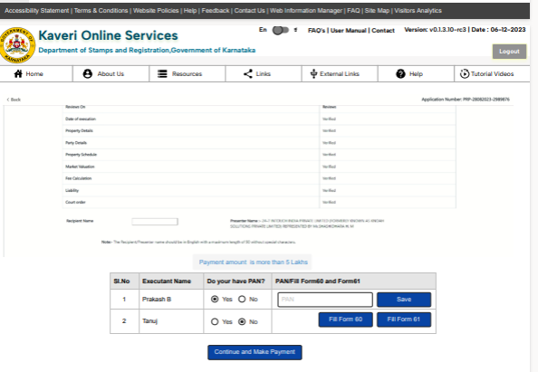

Annexure – 2: Scenarios
Sl. No. | Market value or Consideration. | Is PAN Mandatory | PAN is available for all executants | Description | Expected Outcome
1 | < 20 Lakhs | No | NA | The user is allowed to make the payment | Navigate to Khajane 2
2 | ≥ 20 and < 30 Lakhs | Yes | Yes | All the executants have PAN details, and all the PAN details are successfully verified. Should be allowed for the payment. | Navigate to Khajane 2
3 | ≥ 20 and < 30 Lakhs | Yes | No | When one or more executants do not have the PAN details. Fills and E-Signs on Form 60. Should be allowed for payment. | Navigate to Khajane 2
4 | ≥ 30 Lakhs | Yes | Yes | All the executants have PAN details, and all the PAN details are successfully verified along with SFT Form details.  Should be allowed for the payment. | Navigate to Khajane 2
5 | ≥ 30 Lakhs | Yes | No | When one or more executants do not have the PAN details. Fills and E-Signs on Form 60 along with SFT Form details.  Should be allowed for the payment. | Navigate to Khajane 2
6 | ≥ 20 Lakhs | Yes | Yes | When PAN Authentication fails or the API times out during the verification. | Display the following error message: “Please verify the PAN after 5 minutes”.
7 | ≥ 20 Lakhs | Yes | No | When E-Sign is unsuccessful on forms 60. | Should display a message “Please try again”
6 | ≥ 20 Lakhs | Yes | Yes | When any of the executants doesn’t want to verify the PAN. | Shouldn’t proceed until the PAN is verified.

Annexure-3: Sample payload & Response of Protean PAN API
JSON Request Prototype:
Payload: { " inputData" : [ {“pan”:"",“name”:"",“fathername”:"",“dob”:""}, . . . . ]
"signatre":" “ }
JSON Response Prototype:
Response : { " response_Code" : "", "outputData" : [ {" pan":""," pan_status":""," name":"","fathername":"",“dob”:"","seeding_status":""}, . . . . ] }

Annexure-4: SFT Form details
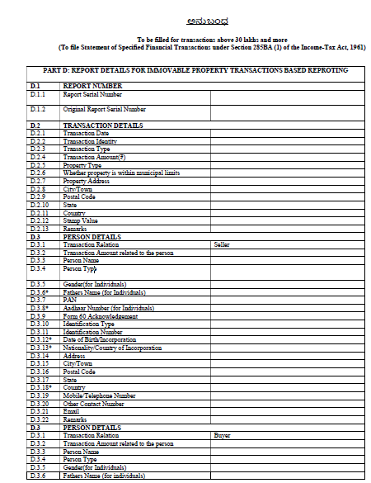

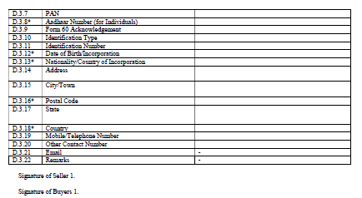

Is Name matching required during PAN authentication?

